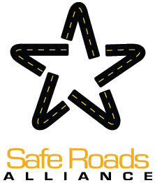

May 4th, 2021

Acting Secretary Pollack

US Department of Transportation

Federal Highway Administration

1200 New Jersey Ave., SE

Washington, DC 20590

Dear Acting Secretary Pollack:

Every year, 40,000 people are killed and millions are seriously injured on our roadways. The members of Safe Roads Alliance in Massachusetts know the impact of this trauma and pain all too well: every one lost a family member or suffered a serious injury in a traffic crash. While we miss your leadership in MA, we are thrilled to see you be a federal leader and trust that you will bring safety to the forefront – a place where it has been missing for too long.

While my father was killed by a distracted driver in 2011, and not in a speed-related crash, I find myself scared to drive on many roads because people are speeding all around us, and the wide roads allow us to be distracted and negligent while driving. Today is my dad’s birthday. He would have been 72 today. It’s been 10 years without him and I miss his kindness, endless support and wisdom every single day.

As those who have paid the highest price for the government’s failure to take action to stem this public health crisis, we urge you to **prioritize safety in every MUTCD recommendation. This core regulatory document impacts nearly every roadway design consideration in the country.**

The current proposed MUTCD draft undercuts the Biden Administration’s stated goal to create a “[road system that is designed to protect its users](https://safety.fhwa.dot.gov/zerodeaths/)” by continuing to elevate operational efficiency for motor vehicles above safe and accessible mobility for people. Without significant revisions and reframing as set out below, the MUTCD will continue to allow tens of thousands to die each year on US roads, four times the rate in the UK and over twice that of France.

We strongly urge FHWA to seize this moment to reframe the MUTCD so it goes beyond merely *permitting* State transportation agencies to build safer roads and instead *empowers* them to build safer roads and addresses fundamental inequities in our land use and transportation systems. Towards this end, the following fundamental problems must be addressed:

1. **The goal of eliminating serious injuries and deaths must be the guiding principle of the MUTCD, by applying a “safe systems” approach to road design.** The Manual unrealistically describes pedestrians and bicyclists who always act “alertly and attentively,” “reasonably and prudently,” and “in a lawful manner” (Section 1A.03). This definition fails to recognize the inevitability of human error, as well as the enormous range of urban street users. Most children, for example, would not meet this standard. By using such descriptive language, the Manual implies that road design need only protect road users whose behavior is without fault. Eliminating such language in Section 1A.03 and redefining the Manual’s primary goal would ensure that the goal of every regulation in the MUTCD is to improve safety and accessibility for people rather than reducing motor vehicle travel delay.
2. **Remove guidance recommending the use of free-flow speeds, including the 85th percentile speed, in setting speed limits.**A substantial body of published research, most recently from [The National Transportation Safety Board (NTSB) in 2017](https://www.ntsb.gov/safety/safety-studies/Documents/SS1701.pdf), shows convincingly that using the 85th percentile approach to establish speed limits leads to increases in vehicular speed over time. While FHWA has downgraded the use of the 85th percentile approach from a requirement to a recommendation, its recommendation sends the message that local engineers should continue using it. Explicitly discouraging, even prohibiting, use of free-flow speed in setting speed limits aligns with FHWA’s intent to heed the most updated and relevant safety research and signals to state DOTs that this approach is no longer nationally endorsed.
3. **Make it safer to cross the street by reforming MUCTD’s language on signal and hybrid beacon warrants so that protected street crossings may be installed before the need becomes apparent after pedestrians lose their lives.**The Manual’s circular signal warrants call for *either* a high volume of people crossing the street without a protected crossing *or* multiple traffic injuries or deaths occurring at the location. Contrast this with motor vehicle signals which are routinely installed based on traffic projections which warrant volumes that are significantly higher than those in other industrialized countries with far lower traffic fatalities, including Canada. In some cases, the Manual’s unreasonably restrictive warrants prevent the installation of safe crossings, even when studies indicate a fatality or serious injury is likely to occur. FHWA should add a simple non-motorized network warrant, which sets out basic guidelines on distance pedestrians can be required to walk to get to a crosswalk (Section 3C.02). FHWA should also follow its own guidance and research buried in the [STEP guide](https://safety.fhwa.dot.gov/ped_bike/step/resources/docs/fhwasa18064.pdf), specifying which streets aren’t safe enough to cross without a signal. (Chapter 4C)
4. **Remove the Manual’s new proposed chapter on Autonomous Vehicles.**The Manual’s new chapter on Autonomous Vehicles (Part 5) places these road users at the top of a new modal hierarchy, by absolving AV companies of the responsibility to build vehicles which keep all road users safe. Upgrading street markings to be compliant with this proposed MUTCD chapter could cost taxpayers billions of dollars. Worse, if the markings are non-compliant where an AV-involved crash occurs, taxpayers will likely foot the bill for that as well. FHWA should remove the new AV Chapter of the MUTCD and instead consult with a diverse set of transportation practitioners, including those who

build and maintain roadways in cities, on appropriate requirements concerning AVs to incorporate into existing sections.

1. **Remove unnecessary restrictions on the use of green paint for bike lanes, red paint for bus lanes, and other colored paint for crosswalks.**Without any basis in research, the proposed Manual prohibits green paint to delineate select bike facilities (Section 3H.06), red paint in transit lanes in contextually appropriate ways without an engineering study (Section 3H.07), and other colored paints to create more visible crosswalks (Section 3H.03). The use of colored pavement in bus and bike lanes is an important and heavily utilized way to delineate space on the street and improve visibility of cyclists and facilitate movement of transit vehicles. Colorful paint In crosswalks increases their visibility and can contribute to a sense of place and community. There is absolutely no evidence indicating that these designs have any adverse safety impacts.
2. **Eliminate geometric design restrictions for urban bikeways.**The MUTCD is not intended to be a geometric design guidance, yet includes dozens of standards and recommendations about bike lane positioning. Rather than include duplicative, conflicting guidance, the MUTCD should instead refer practitioners to best practice guidance such as MassDOT’s [*Separated Bike Lane Planning and Design Guide*](https://www.mass.gov/lists/separated-bike-lane-planning-design-guide)and NACTO’s [*Urban Bikeway Design Guide*](https://nacto.org/publication/urban-bikeway-design-guide/)*.* These best practice guidance documents have been developed with careful input from practitioners with experience and expertise in urban bikeway design, and should be treated as the standard for bikeway design in the US.

The problems with the draft MUTCD described above undercut its efforts to keep all modes of road users safe. The MUTCD needs a bold overhaul which puts safety considerations first if we are ever going to stop the death and destruction on our roadways.

**Finally, we urge you to make the process for revising the MUTCD much more inclusive and transparent**. There should be greater input from crash victims/survivors, city transit agencies, public health experts, childhood development specialists, experts on aging, disability advocates and transportation safety advocates. Towards this end, we recommend that the upcoming revision of the MUTCD be an interim revision for one year, to allow for further stakeholder input before a final revision is considered in a year.

Thank you,

Emily Stein

Daughter of Howard Stein, 61, killed April 7th, 2011 by a distracted driver

Safe Roads Alliance

Massachusetts

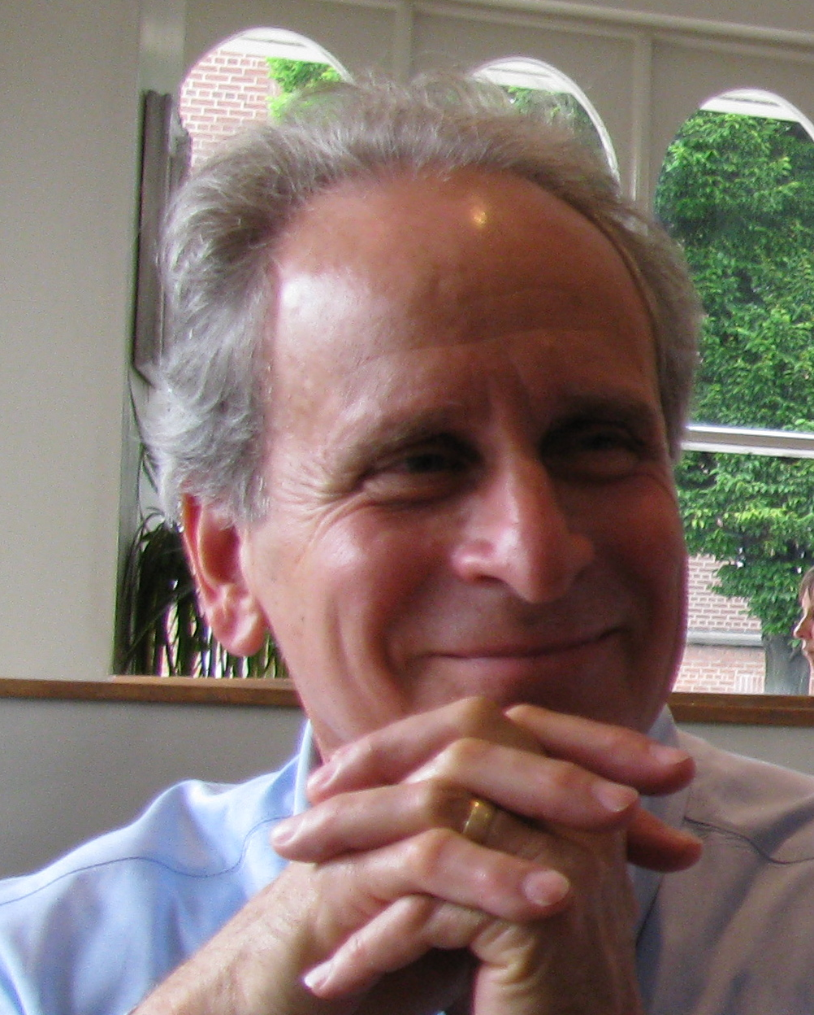

**Howard Stein May 4th, 1949 – April 7th, 2011**

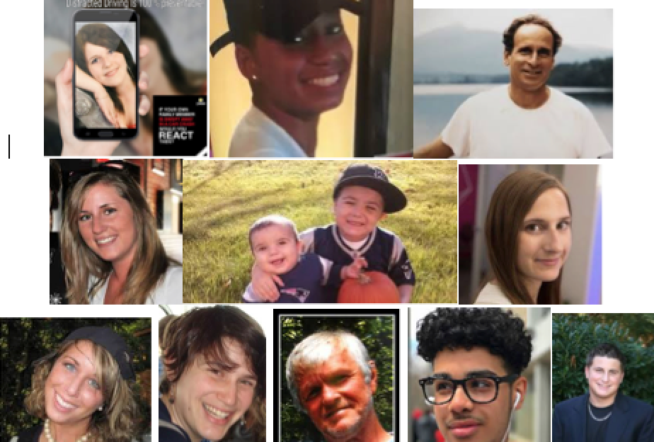

**Victims of preventable traffic crashes in Massachusetts**